Supportive Living Program Medicaid Rates

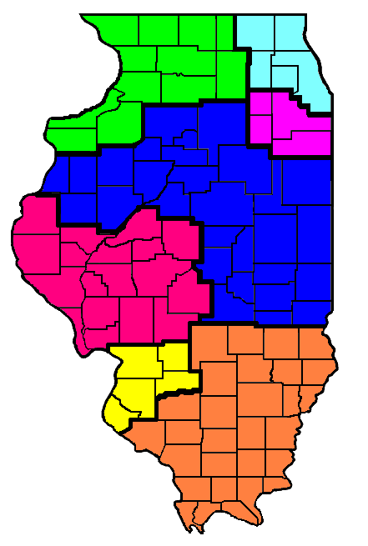
South
Suburb (6)

West Central (3)

St. Louis (7)

Chicago (5)

Central (2)

Northwest (1)

Hardin
Massac
South (4)

Alexander
Pulaski
Pope
Johnson
Union
Gallatin
Saline
Williamson
Jackson
White
Hamilton
Franklin
Perry
Randolph
Wabash
Wayne
Jefferson
Washington
Edwards
Lawrence
Richland
Clay
Marion
Crawford
Jasper
Effingham
Fayette
Clinton
Bond
Monroe
St. Clair
Madison
C
a
l
h
o
u
n

Putnam
Montgomery
Christian
Sangamon
Logan
Menard
Mason
Macoupin
Jersey
Greene
Morgan
Scott
Pike
Cass
Schuyler
Brown
Adams
Hancock
Kankakee
Grundy
Will
Kendall
Clark
Cumberland
Shelby
Coles
Edgar
Douglas
Moultrie
Vermilion
Macon
Champaign
Piatt
DeWitt
Iroquois
Ford
McLean
Tazwell
Livingston
Woodford
LaSalle
Marshall
Peoria
Fulton
McDonough
Stark
Bureau
Knox
Warren
Henderson
Carroll
Henry
Rock Island
Mercer
Whiteside
Lee
Cook
DuPage
JoDavies
Stephenson
Winnebago
Lake
Kane
DeKalb
Ogle
McHenry
Bond

