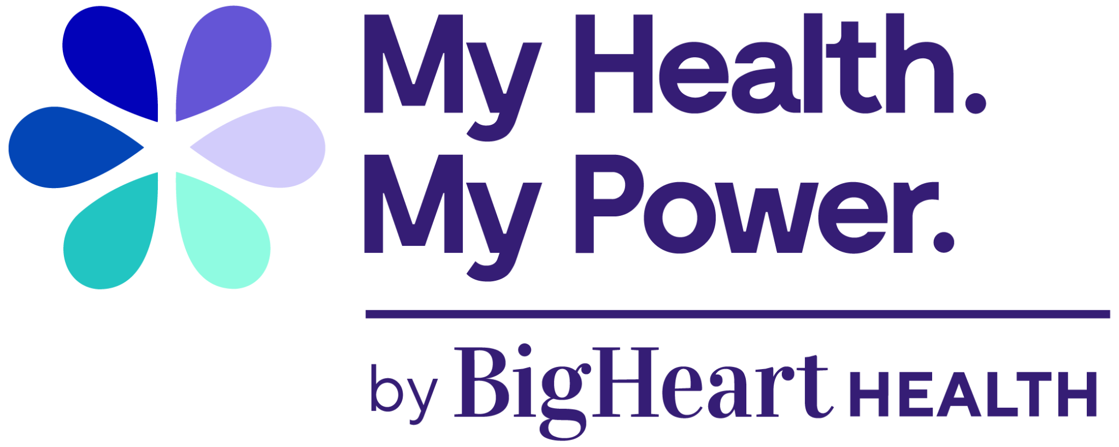

My Health. My Power.
By BigHeart Health

Welcome to a New Kind of Support—Just for You

My Health. My Power. is a free benefit for Illinois Medicaid members in the HealthChoice IL Managed Care program. It makes taking care of your health—and your life—easier with just one phone call.

When you join My Health. My Power., you get a Personal Health Consultant who cares about all of you, not just your doctor visits. They are here to help you every step of the way.

Your Personal Health Consultant can help you:
✅ Schedule doctor and mental health visits
✅ Find help with rent, food, rides, and jobs
✅ Learn how to eat better, lose weight, and manage diabetes or high blood pressure
✅ Get support for stress, anxiety, or feeling sad
✅ Schedule school and sports checkups for your kids
✅ Join live classes about health and emotional wellness

One Call. Real Support. Better Health.

Your life just got easier—and healthier. One call connects you to the help you need.
Take the first step toward a healthier, happier future.

Call 312-210-7820 Today!
711 (TDD/TTY)

To learn more, go to myhealthmypower.com.

Hours of operation are Monday through Friday from 8:30 am to 7 pm.

Help is available for people who are hard of hearing, blind, or speak languages other than English.

If you are experiencing an emergency, call 911 or go to the nearest emergency room.

